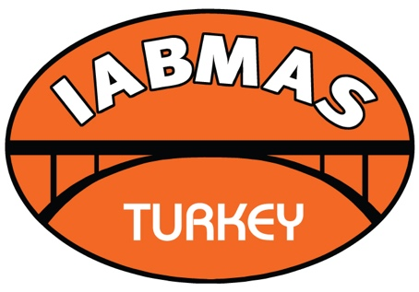
IABMAS Turkey Group

International Association for Bridge Maintenance and Safety (IABMAS)

APPLICATION FOR COLLECTIVE MEMBERSHIP

- NAME OF ORGANIZATION:

- MAILING ADDRESS
STREET:
CITY: |  |  |  |  | STATE:
ZIP-CODE: |  |  |  |  | COUNTRY:
TEL: |  |  |  |  | FAX:

- E-MAIL ADDRESS:

- CONTACT PERSON
NAME:
TITLE (Dr., Mr., Mrs., Ms., Prof.):

- MAILING ADDRESS
STREET:
CITY: |  |  |  |  |  | STATE:
ZIP-CODE: |  |  |  |  |  | COUNTRY:
TEL: |  |  |  |  |  | FAX:
E-MAIL ADDRESS:

- ACTIVITIES COVERED BY YOUR ORGANIZATION (SHORT DESCRIPTION):

- INTEREST IN IABMAS:

- Signature: |  | Date:

Please complete this application and send it to info@iabmas-turkey.org

